Unit 2 - Lesson 8 Assignment

**Mini Assignment - Turtle OVS**

import turtle

turtle.setup(640,640)

window = turtle.Screen()

window.bgcolor("pink")

window.title("Turtle Demo")

pen = turtle.Turtle()

# Draw Circle

pen.penup()

pen.goto(-320, 0)

pen.pendown()

pen.fillcolor("red")

pen.begin_fill()

pen.circle(100)

pen.end_fill()

pen.penup()

pen.goto(-320,40)

pen.pendown()

pen.fillcolor("pink")

pen.begin_fill()

pen.circle(60)

pen.end_fill()

# Draw V

pen.penup()

pen.goto(-200, 200)

pen.pendown()

pen.fillcolor("cyan")

pen.begin_fill()

pen.forward(40)

pen.goto(-120, 50)

pen.goto(-80, 200)

pen.forward(40)

pen.goto(-100, 0)

pen.backward(40)

pen.goto(-200,200)

pen.end_fill()

# Draw -S

pen.penup()

pen.goto(20,200)

pen.pendown()

pen.fillcolor("violet")

pen.begin_fill()

pen.forward(70)

pen.right(180)

pen.circle(20, -180)

pen.backward(20)

pen.right(180)

pen.circle(20, 180)

pen.forward(20)

pen.right(180)

pen.circle(60,-180)

pen.backward(70)

pen.circle(20,-180)

pen.backward(55)

pen.right(180)

pen.circle(22, 180)

pen.forward(20)

pen.right(180)

pen.circle(65, -140)

pen.goto(20,200)

pen.end_fill()

window.exitonclick()

**Mini Assignment - Draw Triangle**

After taking the code for calculating and determining the angles, I made an int input to ask for the length of each side, and stored it so it would calculate the angles first and then print the values. I then positioned my turtle to start at (-50,-50) and made it go forward length A, left Ang A, forward length B, left Ang B, forward length C. However, it is having an issue with forming the triangle so I messed up somewhere in my code on how the pen is moving. I found the fix by subtracting 180 from the angle to get the right amount of left turn I needed for it to form a triangle. Now the issue I'm having is that it will still draw even if the values given do not make a triangle. So, for this edge case, we have to take in account the triangle law so we make an if statement so that it will only draw the triangle if the law is true, and the law states that if a+b > c and a+c> b and b+c > a then it is a triangle. However, if it is false I will print a message saying the given values do not make a triangle.

import math

import turtle

window = turtle.Screen()

window.setup(width=400, height=400) # standardize the size of the screen

pen = turtle.Turtle()

pen.pensize(3)

pen.color('red')

a_len = float(input("enter value for side 'A': "))

b_len = float(input("enter value for side 'B': "))

c_len = float(input("enter value for side 'C': "))

#process the triangles angles

angA = (b_len**2 + c_len**2 - a_len**2) / (2*b_len*c_len)

angA = math.acos(angA)

angA = math.degrees(angA)

angB = (c_len**2 + a_len**2 - b_len**2) / (2*c_len*a_len)

angB = math.acos(angB)

angB = math.degrees(angB)

angC= 180 - angA - angB

if a_len + b_len > c_len and a_len + c_len > b_len and b_len + c_len > a_len:

pen.penup()

pen.goto(-100,0)

pen.pendown()

pen.forward(a_len)

pen.left(180 - angA)

pen.forward(b_len)

pen.left(180 - angB)

pen.forward(c_len)

print("Angle A is ", angA)

print("Angle B is ", angB)

print("Angle C is", angC)

else:

print("The sides provided do not form a triangle.")

turtle.exitonclick()

**Flow of Control**

I chose exercise 7.2 for this demonstration, so I took the while loop I created here and created my own flow of control chart to show how it works from the charts point of view.

from pcinput import getInteger

num = getInteger("please enter your number: ")

counter = 1

while counter <= 10:

counter += 1

result = num * counter

print(f"{counter} * {num} is {result}")

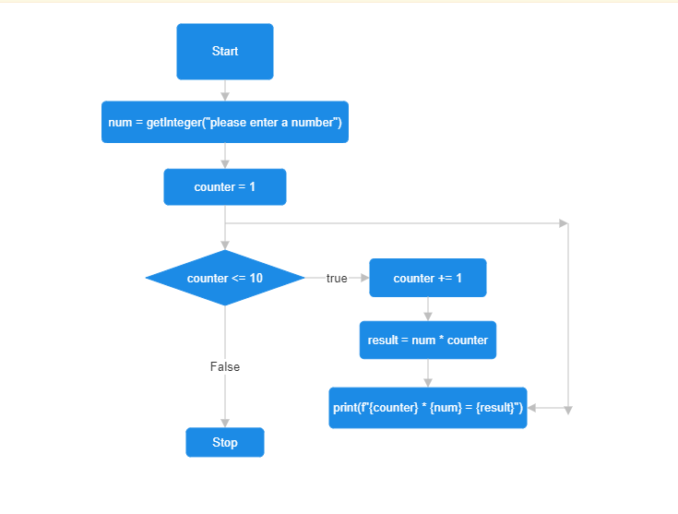

**Boolean Expression / Truth Table**

We use the boolean expression here in this simple login input to check if the entered input is equal to the correct input.

correct_username = "cole"

correct_password = "password"

entered_username = input("please enter your username: ")

entered_password = input("please enter your password: ")

if correct_username == entered_username and correct_password == entered_password:

print("Login successful :)")

else:

print("Login failed")

The way this truth table works is that both values A and B must be true for the output of “A and B” to also come out true, so if one of them is false the output will also be false.

| **A** | **B** | **A and B** |
| --- | --- | --- |
| T | T | T |
| T | F | F |
| F | T | F |
| F | F | F |